**Plugins necessários:**

npm install --save express body-parser

npm install --save-dev @babel/core @babel/cli @babel/node @babel/plugin-transform-runtime @babel/preset-env @babel/register @babel/runtime babel-loader

npm install --save-dev eslint eslint-config-airbnb-base eslint-plugin-import

npm install -g nodemon

npm install -g sequelize-cli

npm install --save path

npm install --save sequelize pg pg-hstore

npm install --save dotenv

**Comandos**:

sequelize init

sequelize model:create --name Book --attributes title:string, price:string, description:string

sequelize db:migrate

**Link tutorial:**

<https://medium.com/@victorsteven/restful-api-with-nodejs-express-postgresql-sequelize-travis-mocha-coveralls-and-code-climate-f28715f7a014>

**Running Endpoints**

Time to see results!

We can test the endpoint using **postman** app or any API testing tool of your choice.

Start up the server, if you terminated it before:

npm run dev (book-app\api)

If you dont know how to use postman, you might need to learn the basics, before continuing.

**a**. **POST** a book:

In the postman address bar enter this:

<http://localhost:8000/api/v1/books> //POST

Change the http method to **POST**, then define the json data to post in the **body**

As an example:

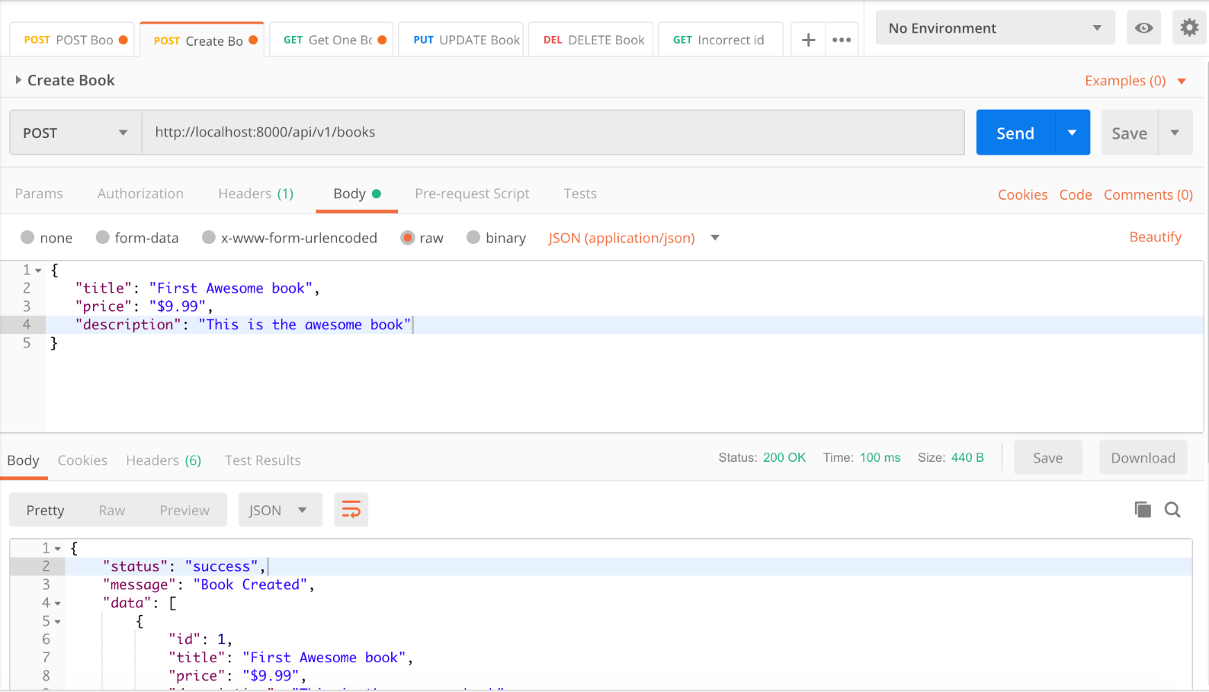

**b**. **GET** all books

<http://localhost:8000/api/v1/books> //GET

**c**. **GET** a particular book

<http://localhost:8000/api/v1/books>/:id //GET

**d**. **UPDATE** a particular book

<http://localhost:8000/api/v1/books>/:id //PUT

**e**. **DELETE** a particular book

<http://localhost:8000/api/v1/books>/:id //DELETE